Last Updated:9/8/2022

This QRG outlines the process for interpreting and approving employee timesheets within Success Factors. This document is for use by supervisors of employees who record time using the Negative or Positive entry methods in SuccessFactors.

Negative Duration Entry: Employees assigned this entry method only record exceptions to their working time, according to their schedule. (Examples: Overtime, Call Back). Each time an exception is recorded, it flows to their supervisor/manager for approval. Employees are instructed to complete all time entries/exceptions directly following their final shift of each week. Additional resources: SuccessFactors Training Page

Positive Duration Entry: Employees assigned this entry method record the number of hours they worked each working day. Employees are instructed to submit all Time Sheets directly following their final shift of each week. Time Sheets in SuccessFactors are in a one-week format. This means for each bi-weekly pay period, supervisors will approve two time sheets per employee. Additional resources: SuccessFactors Training Page

Supervisor Approvals
- Supervisor Approvals are due at 10:00 PM on the Monday following the end of each pay period. See the Payroll Calendars website for current pay period calendars.
- After 10:00 PM on Monday, all timesheets are pushed to Payroll for payment. Timesheets or exceptions that are not approved by a supervisor will remain in the supervisor’s approval queue, will appear on the Delinquent Supervisor Approval report, and will require supervisor approval ASAP (even after payroll has been processed).
- Supervisors have access to run the report SuccessFactors Time Details Report for Managers. This report displays Time and Time Off data and should be used to identify issues and identify actions needed in SuccessFactors by the supervisor or initiate conversations with employees to resolve issues prior to the payroll deadline. Access SuccessFactors - Reporting and scroll to locate report.

Contents
Accessing SuccessFactors 2
Note for Supervisors with Multiple Appointments 2
Approving Time Exceptions / Timesheets 2
Reading and Approving the Timesheet 3
Viewing an Employee’s Timesheet Outside of the Approval Process 4
Editing Timesheet in Employees’ Absence 5

Accessing SuccessFactors
Visit OneCampus and select Employee Launchpad and log in. |  | https://one.purdue.edu/

Note for Supervisors with Multiple Appointments
Supervisors with more than one appointment will have to switch to other account(s) to view pending actions that fall under those appointments by clicking the Change Selected Employment icon on the Navigation bar.

Approving Time Exceptions / Timesheets
Employee Time sheets that require Approval will appear under Approvals. If you have several – they will be stacked. |  | 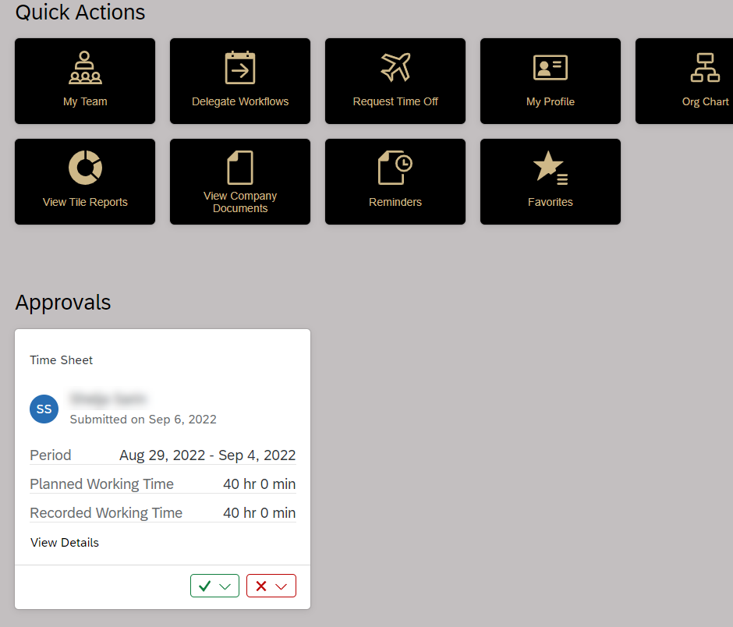
- To view My Workflow Requests to see all your requests and sort and filter as needed – first click View All to separate the requests on to one page.  - Then click the open new window icon page - - that will open the My Workflow Requests.  - Requests can be approved directly from this screen by clicking the green Approve button.  You can always view approvals in the My Workflow Requests by using the checkmark icon (approvals) next to the Search field. |  | 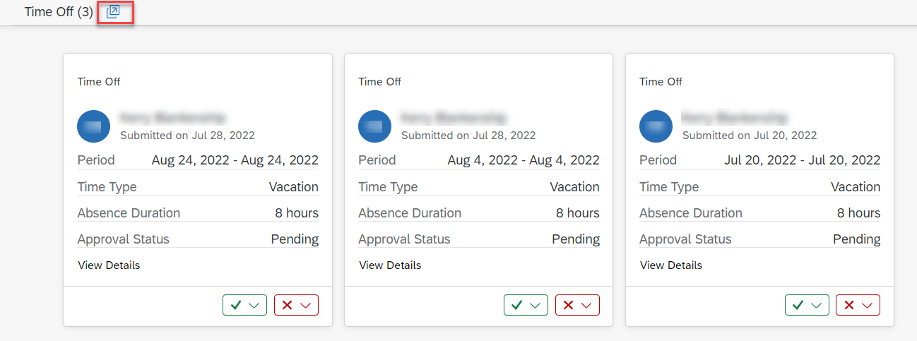  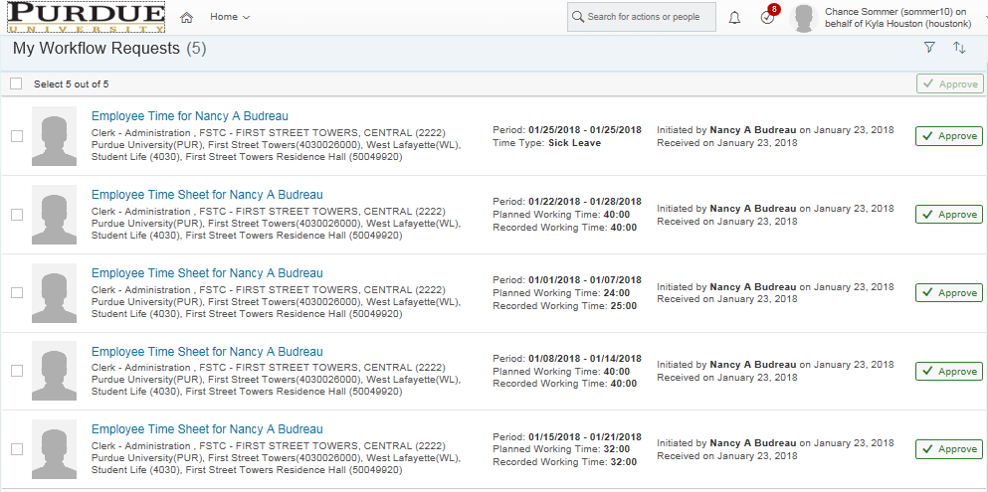
Planned Working Time: Reflects scheduled work time. Does not reflect holidays.  Recorded Working Time: Reflects recorded working time and leaves. Does not reflect premium hours. |  | 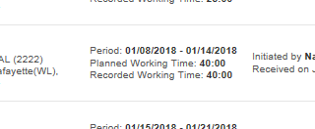
Navigate to the desired timesheet by clicking the associated link. |  | 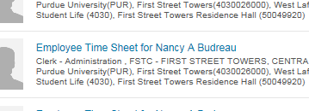

Reading and Approving the Timesheet
The time sheet is divided into two sections: Time Sheet Entry and Time Valuation Result.  Time Sheet Entry: Reflects all hours initiated by employee within their timesheet. This primarily consists of worked hours and Call Back premiums.  Time Valuation Result: Reflects all hours of all pay types recorded for the week. (Pay Types may include overtime, call back, time off requests, etc.) |  | 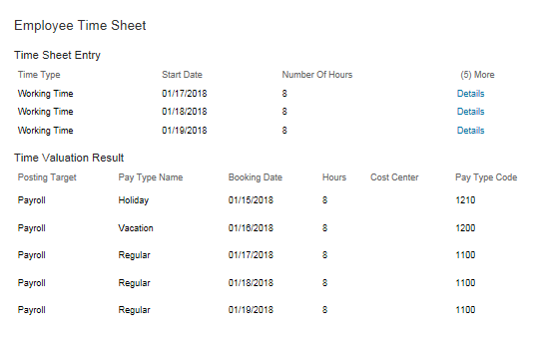
Supervisors should avoid editing employees’ timesheets except in instances that the employee is unavailable. A comment should be posted and the timesheet declined so that the employee can make the correction. If the employee is unavailable, supervisors may edit the timesheet by referring to the Editing Timesheet in Employees’ Absence section of this document.

Only the employee can enter or adjust Time Off requests. Instructions on Requesting Time Off and editing requests can be found on the SuccessFactors Training Page.
Delegate, Decline, and Approve buttons are located at the bottom of the timesheet along with a comment box.

To leave a comment on the timesheet, type the comment and click Post.

Delegate provides option to delegate the approval task to someone else within the organization.

Decline will notify the employee that the timesheet has been declined and needs to be edited and resubmitted.

Approve routes the timesheet to be processed by payroll.

Viewing an Employee’s Timesheet Outside of the Approval Process
A supervisor can use these steps to view an employee’s timesheet at any time, whether there is a pending Approval Request or not.
Under Quick Actions, click My Team tile | 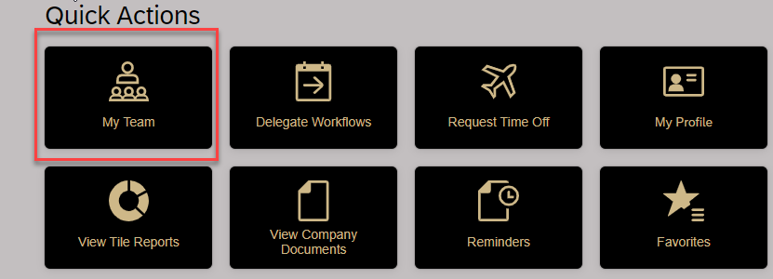
- Select the employee whose timesheet you wish to edit  - Click Take Action button  - Select Time Off | 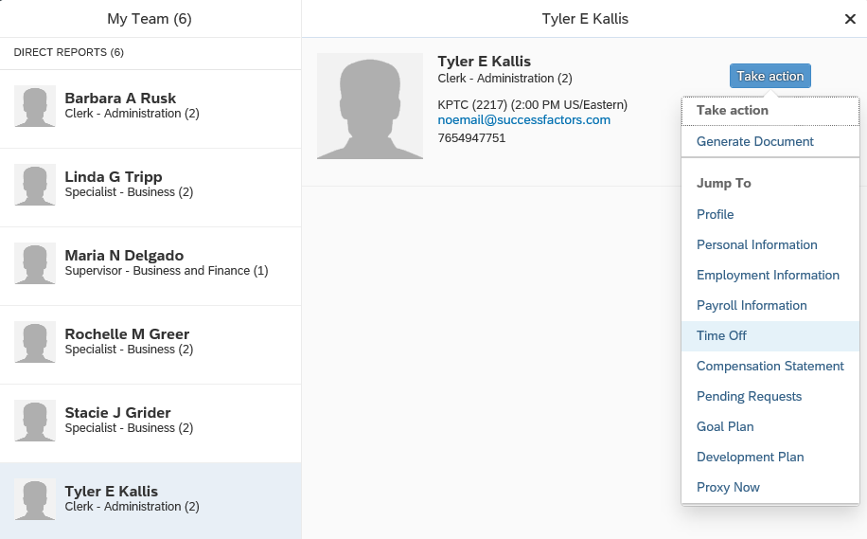  1  3  2
Click Go to Time Sheet | 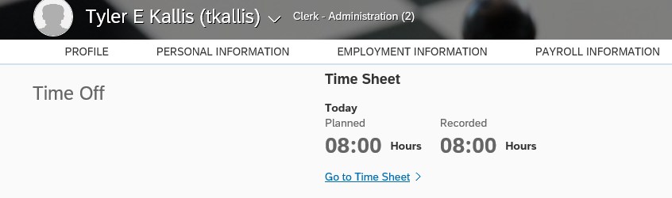

Editing Timesheet in Employees’ Absence
Under Quick Actions, click My Team tile
Select the employee whose timesheet you wish to edit  Click the Take Action button  Select Time Off | 1  3  2
Click Go to Time Sheet
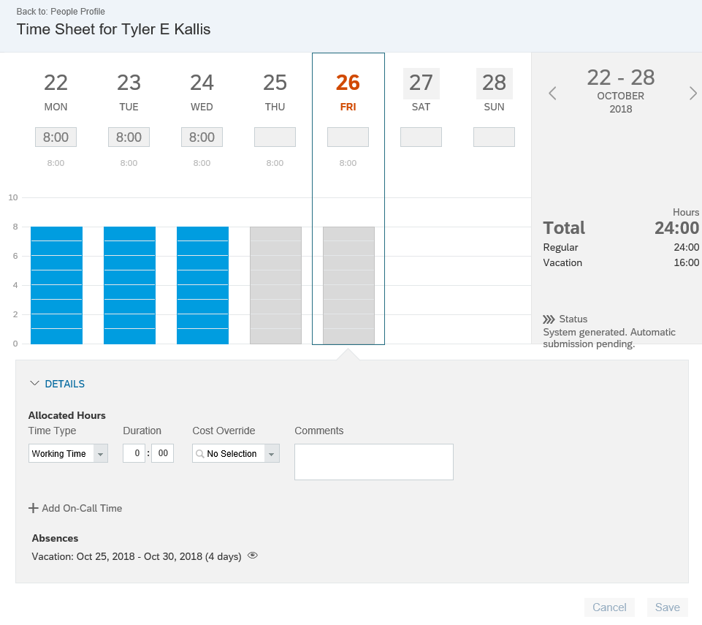

Edit the employee’s time sheet as needed. View appropriate training resources at Time Sheet Resources - Human Resources - Purdue University. After entering or editing time, Save the entries and return to the Approve Requests tile to approve the timesheet.

